PEAS BRIDGE HIGH SCHOOL.

MITOOMA.

**S.1 END OF TERM TWO.**

STUDENT’S NAME………………………………………………………………

STREAM……………………………………………………………………………..

Student’s Signature…………………………………………………………………..

**ENGLISH LANGUAGE**

**PAPER 1**

**Time allowed: 1 hour 45 minutes**

***INSTRUCTIONS*.**

* Attempt all Tasks in this question paper
* For this paper, you shall need a pen, pencil and ruler
* Use a blue or black ball point pen for all work you want to be marked
* Answer All questions using the spaces provided
* Cross out any work you do not want to be marked
* Read each question carefully and answer it as instructed

***ALL ABOUT UKRAINE***

***Where is Ukraine?***

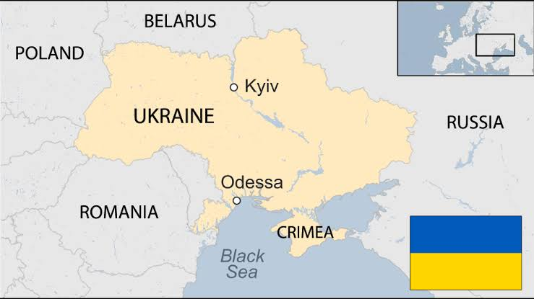

Ukraine is the second-largest country in Europe. It is 603.000km2 and has seven Other countries that it shares borders With. These are Belarus, Russia, Moldova, With. These are Belarus, Russia, Moldova,

Poland, Romania, Hungary and Slovakia. The coast of Ukraine joins to the Seal of Azov and the Black Sea.

Mostly, Ukraine consists of flat plains.

These plains are split into the highland areas and the lowland ares.The average height of the land is 175m above sea level. The largest highland area contains many river valleys and gorges. In the lowland areas in the north of the country, marshland can be found.

Ukraine is also famous for its black soils, which are good for crop production. As a result, Ukraine is one of the largest producers of grain and potatoes in Europe.

***What is the Weather like in Ukraine?***

Ukraine is close to the Atlantic Ocean so it has warm, humid air. It has a mostly continental climate that changes a lot throughout the year.

Furthest from the coast, the Western and northern parts of Ukraine usually see the highest levels of annual rainfall. Along the coast, the climate is much warmer and provides dry, hot summers.

***What is the Capital City?***

The capital city of Kyiv lives in the north of Ukraine. Kyiv is the most populated city in Ukraine and one of the oldest cities in Europe. It is believed that Kyiv has been a centre

for trading since the fifth century. That’s around 1600 years ago About three million people call Kyiv their home and enjoy its beautiful gardens and parts. The Dnieper river runs through the city.

***Did You Know…?***

The city of Kyiv is very leafy and is famous for having lots of chestnut trees.

***Which Animals live in Ukraine?***

The high peaks of the Crimean Mountains and the Ukrainlan Carpathians are on the borders

of Ukraine. These Carpathian Mountains, as well as the other wooded areas of Ukraine, provide homes for lots of wild mammals. These include wolves, wild boar, Iynxes, martens and brown bears.

Beavers, otters, mink, carp and catfish live in the rivers and lakes. The plains are also home to wildlife, including huge numbers of rodents, such as gophers and hamsters, in the east.

***Ukraine’s Culture***

The majority of people speak the Ukrainian language. It is similar to polish as it is part of the Slavic family of languages. Most of the population is ethnic Ukrainian but there are also groups of Russians, Moldovans, Belarusians and Crimean Tatars living in Ukraine.

Eastern Orthodox Christianity is the main religion but Protestantism, Catholicism, Judaism and Islam are also practiced.

Although Ukraine is most famous for its boxing success, football, basketball, rugby and even chess are popular sports. Music is also a large part of the local culture, with Ukraine having many live music venues, such as opera houses.

**Questions.**

1. What is the area of Ukraine? Put a ring around the letter representing the

Correct figure. (2 marks)

1. 63.000km2
2. 603.000km2
3. 36.000km2
4. 306.000km2
5. What is the name of Ukraine’s capital city? Tick one. 92 marks)

Chernobyl Lviv

Kharkis Kyiv

1. Fill in the missing words. (2 marks)

Ukraine is one of the largest producers of ……………………………and………………

In Europe.

1. List two bordering countries of Ukraine. (2 marks)
2. ……………………………………………………………………………………………………

11. ……………………………………………………………………………………………..

5. Which two rodents are given as examples of Ukrainian wildlife? (2 marks)

1 . ……………………………………………………………………………………………………

11. . …………………………………………………………………………………………………

1. Summarise what you have learnt about the Ukrainian weather in 25 words or fewer. (3 marks)

………………………………………………………………………………………

………………………………………………………………………………………

………………………………………………………………………………………

………………………………………………………………………………………

………………………………………………………………………………………

1. Explain why Kyiv is a significant part of Ukraine. (2 marks)

……………………………………………………………………………………………

…………………………………………………………………………………………….

…………………………………………………………………………………………….

1. Compare the highlands and lowland areas of Ukraine in 25 words or fewer. (3 marks)

…………………………………………………………………………………………

…………………………………………………………………………………………

…………………………………………………………………………………………

…………………………………………………………………………………………

1. Precisely state what has currently put Ukraine in the limelight of international news. (Use knowledge outside the read passage) (2 marks)

……………………………………………………………………………………………

……………………………………………………………………………………

……………………………………………………………………………………

***SECTION B***

**Grammar and Function Tasks. Each Task carries one Mark**

1. Which sentence is punctuated accurately? **Put a ring around the letter representing the correct alternative.**
2. Our teacher who, we like very much, is called Miss Diana.
3. Our teacher, who we like very much, is called Miss Diana.
4. What is underlined in the sentence below? **Tick inside one box**.

I’ will bring him a glass of fresh milk,” shirat said.

Uncountable noun

Quantity word

Noun of liquid

1. **Underline** the **superlative form of the adjective** in the sentence below.

Whereas using the internet is a cheaper way of finding information, I think using a

dictionary is the cheapest way.

1. **Add a comma** to the sentence below to make it clear that the scouts are not eating the rabbit.

As the scouts sat around the fire eating the rabbit hid in the bushes.

1. **Re-write** the sentences below as **one sentence** which includesa **relative clause.**

Remember to use the correct punctuation.

The lady has grey hair and glasses. She lives next door to me.

……………………………………………………………………………………………………

……………………………………………………………………………………………………

1. The sentence below has a missing word. **Complete** the sentence by using the correct

**Personal pronoun.**

My mother likes children so much.

1. Read the sentences below. Add the word which links the sentences together to

Create sense.

Sometimes child labour is a necessary evil…………………………….., everything

Possible should be done to make it unnecessary because it deprives one a

meaningful life.

Subsequently Although However Therefore

1. **Draw lines** to match the words /phrases to the correct nouns**.**

A cup of salt

a pinch of milk

Some bananas

a cluster of mangoes

1. In the sentence below, which word best suits the role of synonym for the

Underlined word? **Circle the letter with the best alternative.**

Eating habits are an important tool for social interaction.

1. Styles
2. Etiquette
3. Maners
4. **Circle** the **verb** **of preference** in the sentence below.

Nabukeera and Mu**ri**sho dislike boiled rice.

***SECTION C***

Below is a **Family Tree** drawn by AINE SALMAH DAISY, an S.1 student at Balandiza

S.5. Study it carefully and use it to attempt to the tasks given.

**A C D B**

HAIRAT MBABALI MPIIMA NANTONO

NANKYA BAKERE JOHN ROBINA

Age: 71 Age:83 Age:80 Age:69

Sex: Female Sex: Male Sex; Male Sex:Female

**F K G J F l**

MBABALI BUTETE NAMUBIRU MUJUZI NAMAKULA SENYONDO

SHAFIK AFUSAH SOPHIA BOSCO LEILA TWAHA

Age:52 Age:47 Age:42 Age:48 Age:44 Age;36

Sex:Male Sex;Female Sex:Female Sex;Male Sex:Female Sex;Male

**M I N H**

MUJUZI NAKALUNGI AINE SALMAH MPIIMA

BEN ANNAH DAISY ROWLAND

Age:24 Age:18 Age:14 Age:8

Sex:Male Sex:Female Sex:Female Sex:Male

**Task 1**: Complete the table below by filling in the gaps with the relation, name, age

and code letter given in Salmah’s Family Tree to indicate her relatives. (10 marks)

|  |  |  |  |  |
| --- | --- | --- | --- | --- |
|  | ***RELATION*** | ***NAME*** | ***AGE*** | ***CODE LETTER*** |
| 1 | Maternal Grand-mother |  |  |  |
| 2 | Paternal Grand-mother |  |  |  |
| 3 | Maternal Grand-FATHER |  |  |  |
| 4 |  | Mpiima John |  | **D** |

|  |  |  |  |  |
| --- | --- | --- | --- | --- |
| 5 | **Maternal uncle** |  |  |  |
| 6 |  |  | 44 |  |
| 7 | Salmah’s mother | Namubiru Sophia |  |  |
| 8 |  |  | 8 |  |
| 9 |  | Nakalungi Annah |  |  |
| 10 | Salmah’s Father |  |  | J |
|  |  |  |  |  |

**Task 2.** During Mzee Mpiima John’s 80th birthday celebrations, a family get together is

Organized.Mr.Mujuzi his eldest son is charged with organizing this function. Assuming

you were Salmah’s father, what responsibilities would you assign each of the following

members of Mpiima’s family during the party. State one responsibility for each.(5 marks)

|  |  |
| --- | --- |
| Family Member | Responsibility assigned |
| Mujuni Ben |  |
| Senyondo Twaha |  |
| Mpima Rowland |  |
| Aine Salmah Daisy |  |

***PART D: WRITING***

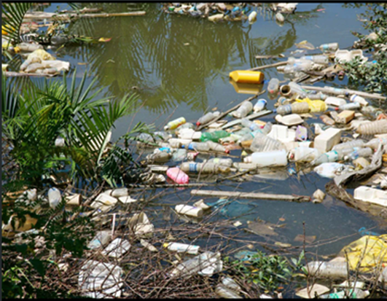

* Basing on the picture above related to environment and pollution, study and note;

1. The type of pollution
2. How it is introduced in the environment
3. The direct effect it has on the environment.
4. How this form of pollution can be overcome

**Your response should be in one paragraph of not less than three sentences.**

**………………………………………………………………………………………………………………………………………………………………………………………………………………………………………………………………………………………………………………………………………………………………………………………………………………………………………………………………………………………………………………………………………………………………………………………………………………………………………………………………………………………………………………………………………………………………………………………………………………………………………………………………**

***THE BEST WISHES***